TRADE – Resources & Template Forms

Table of Contents

Resource No. | Description
1 | TRADE Best Practice Benchmarking Code of Conduct
2 | TRADE Benchmarking Project Agreement Form
3 | Terms of Reference Form
4 | Example of a completed Terms of Reference Form
5 | Guidelines for TRADE Project Meetings
6 | Benchmarking Facilitator’s Team Meeting Preparation Work
7 | Meeting Agenda
8 | Meeting Minutes
9 | Role of Project Sponsor, Team Leader, Benchmarking Facilitator, Administrator and Team Members
10 | SMART Objectives
11 | Simplified TRADE Tasks Form
12 | Assessment of Project Progress
13 | Process Flow Chart
14 | Fishbone Diagram
15 | Performance Measures Record Table
16 | Explanation of Performance Measures Record Table
17 | Example of a Completed Performance Measures Record Table
18 | Prioritisation Matrix
19 | Best Practice Search Form – WORD Version
20 | Approach to Potential Benchmarking Partners Check-list
21 | Example of Questions
22 | Site Visit Preparation Table
23 | Site Visit Agenda Template
24 | Example Letter Preparing Benchmarking Partners for Site Visit
25 | Guidance on Site Visit Interviews
26 | Site Visit Interviewing Tips
27 | Contents of a Benchmarking Report (Short Version)
28 | Contents of a Benchmarking Report (Long Version)
29 | Assessment of Benchmarking Project Questionnaire

RESOURCE 1 – TRADE Best Practice Benchmarking Code of Conduct


TRADE Best Practice Benchmarking Code of Conduct – 2022 Version

Introduction

Benchmarking is a powerful method for breakthrough thinking, innovation, improvement and for delivering exceptional performance results. Benchmarking involves learning from the experience of others and applying this learning to improve performance.

Benchmarking is most successful when following a structured benchmarking methodology such as TRADE. The name of TRADE reminds users to develop strong two-way relationships with other organisations (the benchmarking partners) in order to share or trade information and best practices for mutual benefit.

The methodology guides benchmarking teams to develop a Terms of Reference, review the current situation, learn from best practices, deploy best practices and evaluate the project’s success. The methodology encourages strong engagement with stakeholders to obtain their ideas and input and combine these with the best practices found to develop the most effective solutions or next practices.

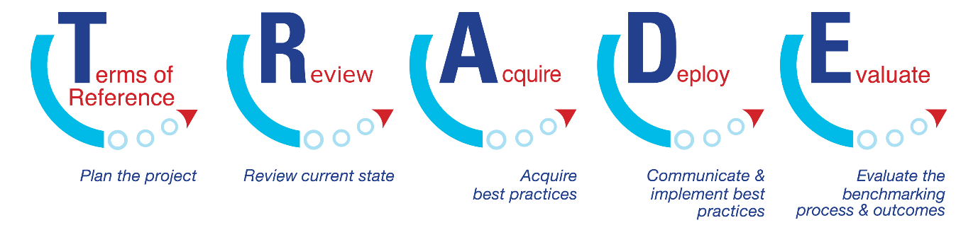

The TRADE Best Practice Benchmarking Code of Conduct builds on previous work undertaken by several organisations and adds further clarity to bring the Code of Conduct up to date. The first Benchmarking Code of Conduct was developed by the American Productivity Quality Centre’s International Benchmarking Clearing House and Strategic Planning Institute Council in 1993. It is now usually referred to as APQC’s Benchmarking Code of Conduct. The second is the European Benchmarking Code of Conduct, developed in 1996, whereby the original wording was modified to consider the rules of European Union competition law. The European Benchmarking Code of Conduct was developed by the European Foundation for Quality Management and a small group of sponsoring organisations. A third version with further modifications was developed by the UK Benchmarking Institute in 2006/7.

Users of the TRADE Best Practice Benchmarking Methodology are expected to follow the Benchmarking Code of Conduct when undertaking a benchmarking project. Adherence to this Code will contribute to efficient, effective and ethical benchmarking.

- Principle of Preparation

  - Learn and follow the stages and steps of the TRADE Best Practice Benchmarking Methodology for professional and effective benchmarking.
  - Understand your own work practices/processes before asking other organisations (benchmarking partners) to share information on theirs.
  - Undertake background research on potential benchmarking partners utilising publicly available resources prior to contacting them. This will help to ensure the benchmarking partner is a good fit for your information request and enable you to ask pertinent questions.
  - Make the most of your benchmarking partner’s time by being fully prepared for each exchange (with an agenda set and questions prepared).
  - Help your benchmarking partners prepare by informing them in advance of your key questions and agenda prior to benchmarking meetings (on-line or face to face).

- Principle of Contact

- Respect the corporate culture of partner organisations and work within mutually agreed procedures.
- Initiate benchmarking contacts through a benchmarking contact, designated by the partner company, if that is the partner’s preferred procedure.
- Agree with the designated benchmarking contact how communication or responsibility is to be delegated during the benchmarking exercise. Check mutual understanding.
- Obtain an individual’s permission before providing his/her name in response to a contact request.
- Avoid communicating a contact’s name in an open forum without the contact’s prior permission.

- Principle of Exchange

3.1 Be willing to share the same type and level of information that you request from your benchmarking partner with the benchmarking partner.
3.2 Communicate fully and early in the relationship to clarify expectations, avoid misunderstanding, and establish mutual interest in the benchmarking exchange.
3.3 Be honest, complete and timely with information submitted.

- Principle of Confidentiality

4.1 Treat Benchmarking findings as confidential to the individuals and organisations involved. Such information must not be communicated to third parties without the prior consent of the benchmarking partner who shared the information. When seeking prior consent, make sure that you specify clearly what information is to be shared, and with whom.
4.2 An organisation’s participation in a benchmarking exchange is confidential and should not be communicated externally without their prior permission.

- Principle of Use

5.1 Use information obtained through benchmarking only for the purposes stated and agreed to with the benchmarking partner.
5.2 Communicating a benchmarking partner’s name with the data obtained or the practices observed requires the prior permission of the partner.
5.3 Contact lists or other contact information provided by benchmarking networks in any form may not be used for purposes other than benchmarking.

- Principle of Legality

6.1 If there is any potential question on the legality of an activity, don’t do it or take legal advice
6.2 Avoid discussions or actions that could lead to or imply an interest in restraint of trade, market and/or customer allocation schemes, price fixing, dealing arrangements, bid rigging or bribery. Do not discuss costs with competitors if costs are an element of pricing. Do not exchange forecasts or other information about future commercial intentions.
6.3 Refrain from the acquisition of information by any means that could be interpreted as improper, including the breach, or inducement of a breach, of any duty to maintain confidentiality.
6.4 Do not discuss disclose or use any confidential information that may have been obtained through improper means, or that was disclosed by another in violation of a duty of confidentiality.
6.5 Do not, as a consultant, client or otherwise pass on benchmarking findings to another organisation without first getting the permission of your benchmarking partner.
6.6 If data and information is to ‘blinded’ and anonymous so that the participants’ identity are protected, it is still necessary to agree with the benchmarking partner(s) on what can be shown and how it can be shown.

- Principle of Completion

7.1 Follow through with each commitment made to your benchmarking partner in a timely manner.
7.2 Complete a benchmarking effort to the satisfaction of all benchmarking partners as mutually agreed.

- Principle of Understanding and Agreement

8.1 Understand how your benchmarking partner would like to be treated and treat him/her in that way.
8.2 Agree how your partner expects you to use the information provided, and do not use it in any way that would breach that agreement.

- Benchmarking with Competitors

The following guidelines apply to Benchmarking with both actual and potential competitors:

- In Benchmarking with actual or potential competitors, ensure compliance with competition law. Always take legal advice before benchmarking with actual or potential competitors and throughout the benchmarking process. If uncomfortable, do not proceed. Alternatively, negotiate and sign a nondisclosure agreement that will satisfy the legal counsel representing each partner.
- Do not ask competitors for sensitive data or cause the benchmarking partner to feel he/she must provide such data to keep the process going.
- Do not ask competitors for data outside the agreed scope of the study.
- Consider using an experienced and reputable third party to assemble and ‘blind’ competitive data.
- Any information obtained from a benchmarking partner should be treated as internal, privileged communication. If "confidential" or proprietary material is to be exchanged, then a specific agreement should be executed to specify the content of the material that needs to be protected, the duration of the period of protection, the conditions for permitting access to the material, and the specific handling requirements that are necessary for that material.

Benchmarking Protocol

Benchmarkers:

- Know and abide by the Benchmarking Code of Conduct.
- For a benchmarking project ensure at least one member of your team has been trained on benchmarking and all team members have at least a basic understanding of benchmarking.
- Follow a recognised benchmarking methodology.
- Prior to initiating contact with potential benchmarking partners, determine what to benchmark, identify key performance variables to study, identify superior performing organisations, and complete a rigorous self-assessment.
- Prepare questions and share your key questions in advance with the benchmarking partner to help the benchmarking partner’s own preparations.
- Possess the authority to share and be willing to share information with benchmarking partners.
- Work through a specified contact and mutually agreed arrangements.

When the Benchmarking process proceeds to direct contact (site visit/virtual meeting), the following behaviours are encouraged:

- Provide meeting agenda in advance.
- Be professional, honest, courteous and prompt.
- Introduce all attendees and explain why they are present.
- Adhere to the agenda.
- Use language that is universal, do not use jargon.
- Be sure that neither party is sharing proprietary or confidential information unless prior approval has been obtained by both parties, from the proper authority.
- Share information about your own process, and if asked, consider sharing study results.
- Offer to facilitate a future reciprocal visit.
- Conclude meetings and visits on schedule.
- Thank your benchmarking partner for sharing his/her process.

Important notice:

This Code of Conduct is not a legally binding document. Though all due care has been taken in its preparation, the authors will not be held responsible for any legal or other action resulting directly or indirectly from adherence to this Code of Conduct. It is for guidance only and does not imply protection or immunity from the law.

------------------------------------------------------------------------------------------------------------------------------------------------------------------
Prepared by the Centre for Organisational Excellence Research Limited, www.coer.org.nz, March 2022. COER are a member of the Global Benchmarking Network.


RESOURCE 2 – TRADE Benchmarking Project Agreement Form

Please complete the form and return to the Team Leader

Project Name: ______________________________________________________________
Team Leader: ______________________________

Project Team Member _____________________________

Agreement

I agree to the following during the period from __/__/__ until __/__/__

A. Commitments:

- To actively participate in the benchmarking project as defined in the project’s Terms of Reference.
- To actively volunteer to undertake project tasks, take ownership of them, and have pride in completing them on time.
- To attend all project meetings (unless for an emergency) and report on project work tasks that I have been assigned.
- To assist other team members complete their work tasks when needed and focus on what is best for the project as a whole.
- See the project through to completion.

B. Benchmarking:

- To abide by the TRADE Best Practice Benchmarking Code of Conduct and its associated Benchmarking Protocol. In particular, to note clause 4.0:
"Principle of Confidentiality. Treat Benchmarking findings as confidential to the individuals and organisations involved. Such information must not be communicated to third parties without the prior consent of the Benchmarking partner who shared the information. When seeking prior consent, make sure that you specify clearly what information is to be shared, and with whom. An organisation’s participation in a study is confidential and should not be communicated externally without their prior permission”.
- To understand and follow the TRADE Benchmarking Methodology and work through the TRADE stages and steps.
- To prepare for meetings by reading through the TRADE Training Notes on the relevant stage or step.
- To record on the TRADE spreadsheet the project’s Terms of Reference, work tasks, progress, findings, and information relevant to the project so that an accurate documentation of the project is maintained.

C. Team Meeting Ground Rules:

- Keep issues that arise in meetings in confidence within the team unless otherwise indicated.
- Give everyone the opportunity for equal participation.
- Be open to new approaches and listen to new ideas.
- Practice active, effective listening skills.
- Keep discussions on track.
- Use visual means such as drawings, charts, and tables to facilitate discussions.
- Use team tools when appropriate to facilitate problem solving.
- Ensure new learning is captured and recorded.
- Make decisions based on data whenever feasible.
- Seek to find the needed information or data.
- Discuss criteria (such as cost, time, and impact) for making a decision before choosing an option.
- Ask all team members if they can support a decision before the decision is made.

D. Meeting Guidelines:

- Meetings will begin and end on time
- Team members will come to the meetings prepared
- Agenda items for the next meeting will be discussed at the end of each meeting
- Meetings will be held every ____ days/weeks/months
- Meetings will be called by ______________________
- Agendas will be issued _____ days in advance of meetings by ______________
- Meetings will be facilitated by ______________
- ____________ will write and issue minutes within ____ days of the meeting
- ____________ will update the TRADE spreadsheets and issue them within ____ days of the meeting

Signed: _____________________________ Date: ________________

RESOURCE 3 – Terms of Reference Form

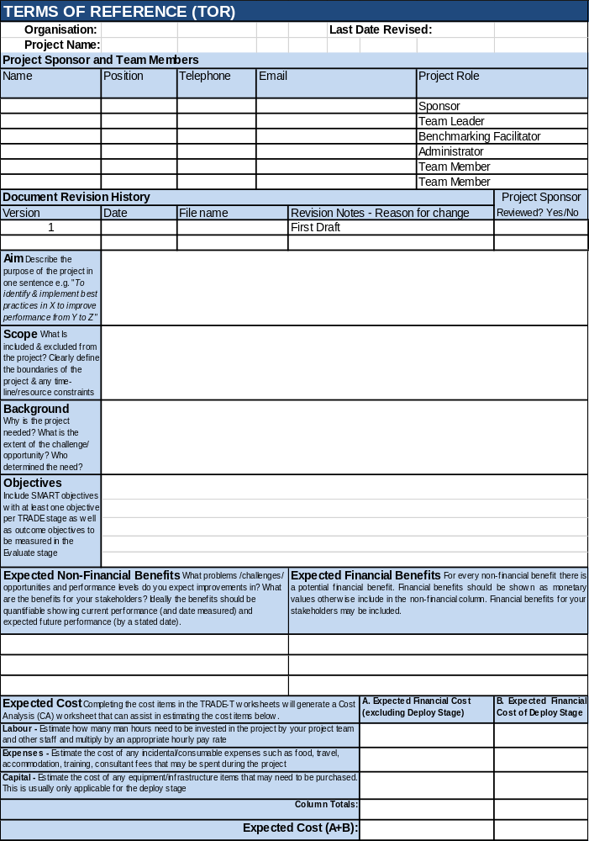

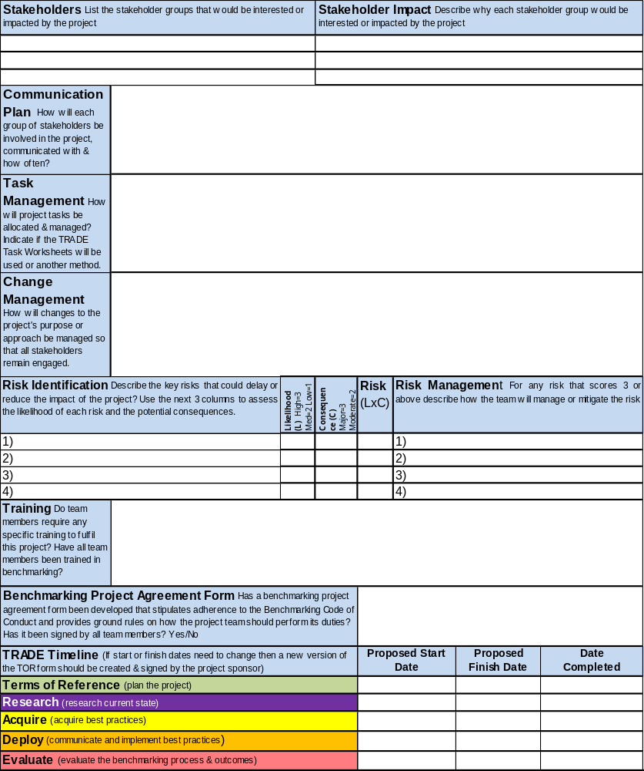

RESOURCE 4 – Example of a Completed Terms of Reference Form
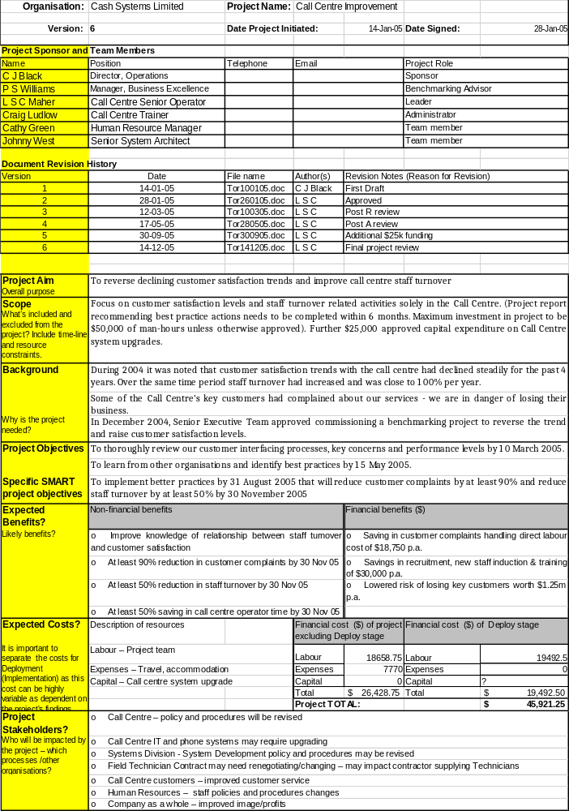

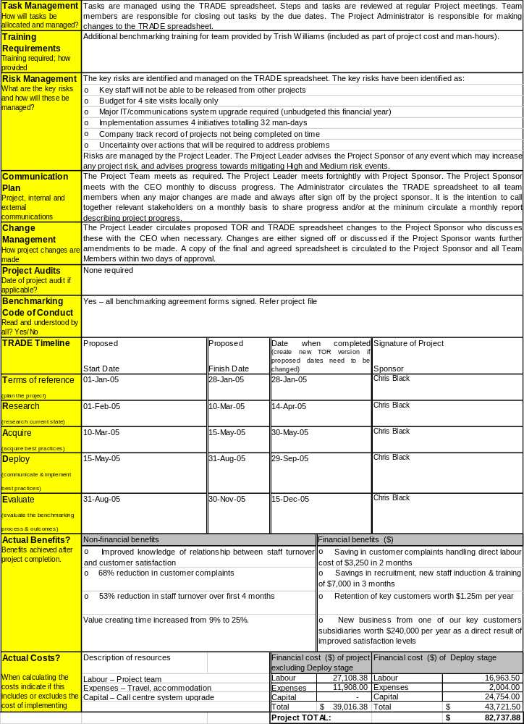
RESOURCE 5 – Guidelines for TRADE Project Meetings

- Operation

Project meetings operate in an open, challenging, and professional forum.

The Team Leader usually chairs the meeting. The Agenda of the meeting is usually set by the Team Leader and Benchmarking Facilitator after consultation with other Team Members.

The Administrator organises the meeting, sending out timely advice to attendees and providing reports and other information to project members at least one week prior to the meeting. The Administrator takes minutes and records action items.

The meeting room should have a computer and data projector so that forms and the TRADE Spreadsheet are visible on a screen ready for discussion.

- Meeting Agenda
The regular meeting agenda consists of;

- Review open TRADE tasks (from TRADE tasks spreadsheet, these are tasks that have yet to be completed)
- Other Matters (raised during the meeting)
- Review of Meeting (lessons learnt from the meeting)
- Next Meeting (When, where, who involved)

Where a special meeting is held that differs from the agenda above, advice will be sent out prior to the meeting.

- Minutes
Minutes are kept and include the following as a minimum;
- Meeting location
- Time
- Attendees and apologies
- Attendees contact details
- Agenda items (as above where meeting is a regular TRADE project meeting)

The Administrator sends out the meeting minutes to the project team requesting that they provide advice of any changes, errors or omissions within 5 working days of the meeting.

- TRADE Tasks
TRADE tasks record work that is required to be carried out for each TRADE step with the names of the team members responsible and projected completion dates. These tasks are usually agreed at project meetings.

The Benchmarking Facilitator or Administrator updates the Task Worksheets in the TRADE
Spreadsheet during the meeting and shows these on a data projector screen. This will help everyone share their comments on the project.

As existing tasks are completed the date the task was completed and the outcome are recorded.

The Administrator emails the updated TRADE Spreadsheet and Minutes of meeting to the project team requesting that they take action as requested.

RESOURCE 6 - Benchmarking Facilitator’s Team Meeting Preparation Work

This document outlines the work a Benchmarking Facilitator should undertake prior to, at team meetings, and after meetings to make sure that the TRADE methodology is followed and the meetings are effective.

Before the meeting
- Review which TRADE stage and step the project is at
- Read the TRADE Training notes for the relevant stage and step
- Review any videos on the BPIR.com for this stage and step
- Prepare how you will facilitate the meeting and support the Team Leader
- Discuss the meeting in advance with the Team Leader and agree on each other’s role at the meeting
- Practice as necessary any tools/methods (such as brainstorming, fishbone diagrams, prioritization tools) that you may use at the meeting
- Make sure an Agenda for the meeting has been prepared (this role may be allocated to the Administrator or Team Leader)
- Make sure the TRADE spreadsheets are up-to date so that they can be reviewed at the meeting.

At the meeting
- Facilitate the meeting and/or provide support to the Team Leader at the meeting
- Make sure that time is spent reviewing and updating the TRADE Spreadsheet:
- Check whether people assigned to specific tasks have completed their work
- Allocate new tasks to team members and record these on the TRADE Task Worksheets.
- Review whether the TOR can improved/refined as a result of what you have found out since the last meeting.
- Make sure a date/time has been agreed for the next meeting.

After the meeting

- Ensure that everyone receives the latest copy of the TRADE Spreadsheet within two days of the meeting so that they know their tasks.
- Help Team Members with their tasks as required.

RESOURCE 7 – Meeting Agenda

Project Name:
Meeting Date: |  |  |  |  | Location:
Start Time: |  |  |  |  | Host:
Resources Required:
Start Time | Item |  |  |  |  | Responsible |  | Preparation Work Required
 | Review open TRADE tasks
 | Other matters
 | Review of meeting
 | Next meeting
Materials Attached
Directions to the venue attached? Yes/No
Enquiries contact If you have any enquiries regarding this meeting, please contact
(name) |  |  |  | (organisation) |  | (phone) |  | (e-mail address)

RESOURCE 8 – Meeting Minutes

Project Name:

Minutes of Meeting

Date |  |  |  |  | Time
Venue
Project Title
 |  | (name) |  | (contact details)
Leader
Administrator
Team member
Items provided prior to the meeting (including reading materials):

Items handed out at meeting:

Agenda Item 1 – Review open TRADE tasks
- (summarise discussion and decisions)
(sub-point)
Action to be taken |  |  |  |  |  |  | Responsible | Target Date
Agenda Item 2 – Other matters
- (summarise discussion and decisions)
(sub-point)
Action to be taken |  |  |  |  |  |  | Responsible | Target Date
- Agenda Item 3 – Review of Meeting
- (summarise discussion and decisions)
(sub-point)
Action to be taken |  |  |  |  |  |  | Responsible | Target Date
Next Meeting
Date |  | Time | Location |  |  |  |  | Host
(any additional information regarding the next meeting)
Enquiries: Please contact
 |  |  | (name) | (organisation) |  |  | (phone) | (e-mail)

RESOURCE 9 – Role of Project Sponsor, Team Leader, Benchmarking Facilitator, Administrator and Team Members

Role | Description | Ideal Skills
Project Sponsor | - Acts as liaison between senior management and the project team  - Ensures the project is consistent with organisational objectives  - Ensures that the expected project benefits provide a good return in comparison to the level of resources invested  - Ensure that appropriate resources are available to undertake the project  - Monitors the progress of the project and helps the project team overcome any obstacles that are encountered. | - Leadership (Decision making, Influencing, Communicating, Motivating)  - Vision  - Business Awareness  - Conflict Resolution  - Benchmarking Experience
Team  Leader | - Liaison point with the project sponsor and project team  - Leads the team and ensures that the TOR is created and executed  - Manages project risks, resources and issues  - Monitors and reports progress of the project | - Leadership skills (Decision making, Influencing, Communicating, Motivating)  - Delegation  - Integrity  - Project management skills  - Benchmarking experience
Benchmarking Facilitator | - Provides specialist advice and training on how to implement TRADE  - Ensures all TRADE steps and stages are followed  - Updates TRADE Spreadsheet  - Assists in finding benchmarking partners through developing strong networks | - Trained in TRADE  - Benchmarking expertise  - Analytical skills  - Networking skills  - Project management skills
Administrator | - Supports the Team Leader and Benchmarking Facilitator in completing administrative tasks as required.  - Organises project team attendance at meetings and books meeting rooms  - Maintains project files and documents ( updates TRADE Spreadsheet if not undertaken by the benchmarking facilitator)  - Records minutes | - Experienced administrator
Team Member(s) | - Provides technical input, experience and ideas  - Undertakes the assigned project work  - Communicates to Team Leader if any issues | - Process owner /stakeholder  - Technical expertise  - Benchmarking experience  - Team skills  - Highly motivated to complete work on time

RESOURCE 10 – SMART Objectives
The acronym SMART has a number of slightly different variations, which can be used to provide a more comprehensive definition for objective setting.
Two examples of SMART are provided below:
Example 1 - SMART
S - Specific, significant, stretching
M - Measurable, meaningful, motivational
A - Agreed upon, attainable, achievable, acceptable, action-oriented
R - Realistic, relevant, reasonable, rewarding, results-oriented
T - Time-based, timely, tangible, trackable
Example 2 - SMART
Specific
• Well defined
• Clear to anyone that has a basic knowledge of the project

Measurable
• Know if the objective is obtainable and how far away completion is
• Know when it has been achieved

Agreed Upon
• Agreement with all the stakeholders what the objectives should be

Realistic
• Within the availability of resources, knowledge and time

Time Based
• Enough time to achieve the objectives
• Not too much time, which can affect project performance

RESOURCE 11 – Simplified TRADE Tasks form (It is recommended that teams use the TRADE Spreadsheet for planning & managing the project)

TRADE Stages | Tasks /Steps | Resource Required | Person Responsible | Planned  Start  Date | Planned Finish  Date | Actual  Finish  Date | Result Obtained (if applicable)
Terms of reference
_{(plan the project)}

Review _{(review current state)}

Acquire
_{(acquire best practices)}

Deploy (communicate & implement best practices)
Evaluate
(evaluate the benchmarking process & outcomes)

RESOURCE 12 – Assessment of Project Progress

Stage of TRADE being evaluated?

In your opinion what went well during this stage of the project?
In your opinion, what did not go so well?

If you were to repeat this stage of the project, what changes would you make?
Do you understand your role in the project?
Can you fulfil your role? (in terms of your time and knowledge of the project)
Are there any issues that should be brought to the attention of the project sponsor?
Are you happy with the TOR or should some changes be made?
Was the stage completed to your satisfaction?
Very Poor | Poor | OK |  | Good | Very Good
♦ | ♦ | ♦ |  | ♦ | ♦
Explain your response if you indicated Very Poor or Poor

What is your assessment of the guidance you and the project received from the Benchmarking Department? (in terms of training and mentoring)
Very Poor | Poor | OK |  | Good | Very Good
♦ | ♦ | ♦ |  | ♦ | ♦
Explain your response if you indicated Very Poor or Poor

Any other comments?

Thank you for taking the time to complete this questionnaire

RESOURCE 13 – Process Flow Chart

A process flow chart consists of a process start (or inputs), stop (or outputs) and units of activities or action steps in between. It represents the entire process at a high or detailed (depending on your use) level of observation. It can serve as an instruction manual or a tool for facilitating detailed analysis and optimization of workflow and service delivery.
Examples of flow charting symbols are shown in the following table.

Symbol | Definition
Basic symbols
 | The Terminal Shape shows the start or end of a process, therefore the entry point of your flowchart and the exit point such as "submit inquiry" or "receive product"
 | An arrow coming from one symbol and ending at another symbol represents that control passes to the symbol the arrow points to. The line for the arrow can be solid or dashed. The meaning of the arrow with dashed line may differ from one flowchart to another.
 | The rectangle is used to show a process, task, action, or operation. It shows something that has to be done or an action that has to be taken. The text in the rectangle almost always includes a verb.
 | Decision point between two paths; Contains a question, with ‘Yes’ or ‘No’ as possible options
 | Reference to another Flow Chart; Contains reference to the page, or process.
Optional additional symbols
 | A parallelogram is used to show data input or outputs. Examples of input are receiving a report, getting an e-mail, getting an order, receiving data in some format, etc. Examples of output are generating a report, sending an e-mail or faxing a message.
 | A rectangle with a curved bottom represents a document or report. The curve on the bottom is sometimes drawn differently as shown in the Alternate Document below. Now you may ask, "What if the document is an output.

When working in a team it is important to agree on which flowcharting shapes to use. There are no universal standards in flowcharting. There have been ISO standards written, like ISO 5807 and DIN 66001, but they were largely ignored. It is important that people reading a flowchart understand the information it is trying to convey. Using more than the basic shapes often confuses people and adds nothing to the overall goal of your project. Flowcharts can be helpful in understanding a process. The goal should be understanding and improving the process and not be just generating flowcharts.

The following example is of the TRADE benchmarking process described using a process flow chart;
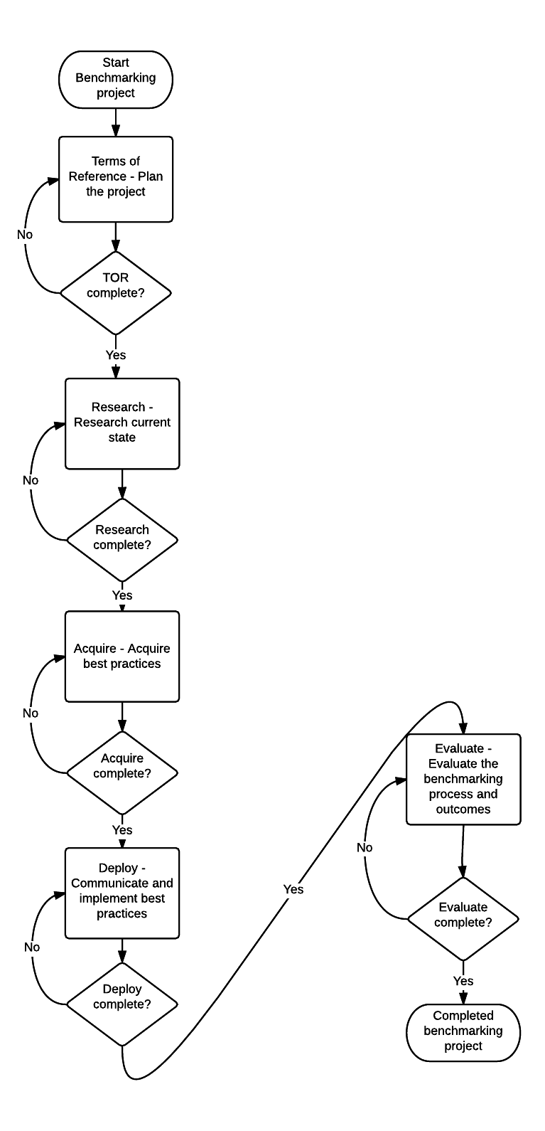

RESOURCE 14 – Fishbone Diagram

There are four steps to using the diagrams.
- Identify the problem.
- Work out the major factors involved.
- Identify possible causes.
- Analyze your diagram.

Use a piece of paper or the Fishbone Worksheet in the TRADE Spreadsheet.

Step 1: Identify the Problem

First, write down the exact challenge or opportunity. Where appropriate, identify who is involved, what the problem is, and when and where it occurs. Then, write the problem in a box on the right-hand side of a large sheet of paper, and draw a line across the paper horizontally from the box. This arrangement, looking like the head and spine of a fish, gives you space to develop ideas.

Step 2: Work Out the Major Factors Involved

Identify the factors that may be part of the problem. These may be systems, equipment, materials, external forces, people involved with the problem, and so on. Try to draw out as many of these as possible. As a starting point, you can use models such as the McKinsey 7S Framework (which offers you Strategy, Structure, Systems, Shared values, Skills, Style and Staff as factors that you can consider), the 4Ps of Marketing (which offers Product, Place, Price, and Promotion as possible factors) or the 6Ms which are shown on the Fishbone Worksheet in the TRADE Spreadsheet (Management, Man, Method, Measurement, Machine, and Material).

Brainstorm any other factors that may affect the situation. Then draw a line off the "spine" of the diagram for each factor, and label each line.

Step 3: Identify Possible Causes

For each of the factors you considered in step 2, brainstorm possible causes of the problem that may be related to the factor. Show these possible causes as shorter lines coming off the "bones" of the diagram. Where a cause is large or complex, then it may be best to break it down into sub-causes. Show these as lines coming off each cause line.

Step 4: Analyze Your Diagram

By this stage you should have a diagram showing all of the possible causes of the problem that you can think of. Depending on the complexity and importance of the problem, you can decide which of these to investigate further at the moment and/or which ones to include as part of the benchmarking project. In the Acquire stage of TRADE it is useful to review the diagram to make sure that questions to the benchmarking partners cover all areas of concern.

Tip:

A useful way to use this technique with a team is to write all of the possible causes of the problem down on sticky notes. You can then group similar ones together on the diagram.
This approach is sometimes called CEDAC (Cause and Effect Diagram with Additional Cards).

RESOURCE 15 – Performance Measure Record Table

Name of measure
Type of measure
Purpose
Relates to
Benchmark

Target
Current performance
Formula
Frequency
Who measures?
Source of data
Who acts on the data?
What do they do?
Notes and comments

RESOURCE 16 – Explanation of Performance Measure Record Table

Name of the measure | The title of the measure. A good title is self-explanatory, avoids jargon and explains what the measure is and why it is important
Type of measure | Record here the type of measure. There are three types of measures:  Key Result Indicators (KRIs). These include measures like customer satisfaction, net profit before tax, profitability of customers, employee satisfaction, return on capital employed. The common characteristic of these measures is that they are the result of many actions. They give a clear picture of whether you are travelling in the right direction. They do not however tell you what you need to do to improve these results. Thus KRIs provide information that is ideal for the governance board, therefore to those not involved in day to day management.  Performance Indicator (PI). These tell you what to do. PIs lie beneath KRIs and could include: profitability of the top 10% of customers, net profit on key product lines, % increase in sales with top 10% of customers, no. of employees using a suggestion scheme.  Key Performance Indicators (KPIs). Key performance indicators are a set of measures focussing on those aspects of performance that are the most critical for the current and future success of the organisation. They have six characteristics:  - measured frequently e.g. daily or weekly  - acted upon by CEO and senior management team  - all staff understand the measure and what corrective action is required  - responsibility can be tied down to an individual or team  - significant impact (on more than one objective)  - has a positive impact (on other performance measures)
Purpose | If a measure has no purpose, why introduce it? Example purposes: 1. To enable you to monitor the rate of improvement thereby driving down the total cost. 2. To ensure that enquiries from the public are responded to within a specified time-frame. 3. To stimulate improvement in a suppliers performance. 4. To increase the use of a product or service. The purpose of a KRI is to provide the governance board with overall performance information.
Relates to | Identify the business objectives that the measure relates to. As with purpose, if the measure being considered does not relate to any business objective, why introduce it?
Benchmark | What is best practice performance for this measure? Have you managed to find a benchmark? The benchmark should help you set an appropriate target.
Target | Targets specify the levels of performance needed and the timescales within which they need to be achieved. Example targets: 1. X% improvement year on year. 2. Y% reduction during the next 12 months. 3. Achieve Z performance by the end of next year.
Current performance | Record your organisation’s current performance here.
Formula | How something is measured will affect the way people behave. An appropriately defined formula should drive people towards good business practice. Beware of the formula that stimulates behaviour you do not want.
Frequency | The frequency with which performance should be recorded and reported is a function of the importance of the measure and the volume of data available
Who measures? | This box should identify the person who is to collect and report the data
Source of data | This box should specify where to get the data from. If you want to see how performance changes over time, then you must get data from the same source each time.
Who acts on the data? | This box should identify the person who is going to act on the data.
What do they do? | Without some action here, the measure is pointless. You may not be able to detail the action to be taken if the performance proves either acceptable or unacceptable as the detail may depend on the context at the time. You can define, in general, the management process to be followed in the case of acceptable or unacceptable performance. Example. 1. Set up a continuous improvement group to identify reasons for poor performance and to make recommendations as to how it can be improved.
Notes and comments | Any specific features, outstanding issues, specific problems, to do with the measure.

RESOURCE 17 – Example of a Completed Performance Measures Record Table
Name of the measure | First Call Resolution (FCR)  FCR is the average percentage of calls that are closed out by the customer as complete during the first customer call made on one issue to the customer service centre.
Type of measure | KPI
Purpose | To enable the monitoring of a key influence on customer satisfaction and operational costs
Relates to | Raising levels of customer satisfaction
Benchmark | 95%
Target | 75% by 1 Jan 2006; 85% by 1 Jan 2007; 90% by 1 Jan 2008
Formula | The total number of calls closed out for the week, divided by the total calls received by the customer service centre for the week.
Current performance | 70%
Frequency | Measured weekly and reported monthly
Who measures? | Latoya Maher, Call Centre Senior Operator
Source of data | FCR weekly report from Call Centre business objects reports folder on O: drive
Who acts on the data? | Latoya Maher, Call Centre Senior Operator
What do they do? | Update FCR trend with weekly report data and circulate graph (pdf) to Operations Division management team.  If two successive weekly figures trend downwards, an improvement request shall be raised in the Process Improvement System.
Notes and comments | - Check weekly data files for correct dates  - Check raw data if first report produces unexpected result based on present trends.  - In case of problems contact Johnny West of IT before proceeding

RESOURCE 18 – Prioritisation Matrix

What is it?
A Prioritization Matrix is a useful technique to use for achieving consensus about an issue. In benchmarking the Matrix is useful for helping to rank and select the particular practice, process or issue for benchmarking.

Who uses it?
Members of your team or other stakeholders can participate. .

Why use it?
To determine the specific practice, process, or issue that is the most pressing problem.

When to use it?
It is important when completing the matrix that facts form the basis of the ratings rather than opinions – this is why it is important to conduct a though review of the practice/process/issue before rating the importance of each practice/process/issue.

How to use it:
- Identify all the practices/processes/issues that may need to be improved.
- Determine the criteria by which the success of the practices/processes/issues will be assessed.
- Conduct an assessment meeting (with those that understand, are affected by, and/or responsible for the practice/process/issue). Use facts (or opinions if facts are not available) to rate the practice/process/issue.
- Complete the Prioritization Matrix chart:
Practice/ process/ issue | Frequency of problems with process/issue  (1 = Low, 5 = Moderate, 10 = High) | Importance of solving the problem/issue  (1 = Low, 5= Moderate, 10 = High) | Feasibility of solving the problem/issue  (1 = Low, 5= Moderate, 10 = High) | Total Score  (FxIxF)
- In the first column, write down the practices/processes/issues of concern in the area targeted for improvement.
- In the second to fourth columns, define your criteria. Examples of some typical criteria are:
  - Frequency: How frequent is the problem? Does it occur often or only on rare occasions?
  - Importance: From the point of view of the users or customers (internal or external), what are the most important problems or opportunities to resolve? Which problems or opportunities will save the most money/time or create the most money/time for the organisation?
  - Feasibility: How realistic is it that the problem/opportunity can be resolved? Will it be easy or difficult?
You can choose other criteria if they better fit the situation you are discussing. For example, for a more quantitative comparison, you could use cost, amount of time, or other numerical indicators as the criteria.
- Agree on the rating for each practice/process/issue based on the facts available. The criteria rating scores are multiplied together for each practice/process/issue to obtain a Total Score.
- Rank each practice/process/issue in order of importance based on the Total Score. The practices/processes/issues that score the highest should be focussed on more in the benchmarking project.

RESOURCE 19 – Best Practice Search Form

The Best Practice Search Form is useful for structuring your internet search for best practices and benchmarking partners.
The form can be used to record:
- best practices (you may find articles, reports or videos on your topic that explain partially or in full a best practice, in either case it is important to find the contact details of the person/team behind the best practice if you would like them to become a benchmarking partner).
- performance metrics and data (you may find relevant performance metrics and benchmark data related to your topic. This information may help you to decide on the performance measures to use for your project and/or identify organisations that are achieving a high level of performance that you would like to approach to become a benchmarking partner)
- potential benchmarking partners (benchmarking partners are organisations that you would like to contact and learn from. You may find potential benchmarking partners when searching for best practices or benchmark data or you could conduct specific searches for award winners in your topic area. If you would like an organisation to become a benchmarking partner it is important to identify the director/manager who appears to be responsible for the best practice using resources such as Linked-In to find their contact details).
- experts (these may be academics, consultants, authors of reports/books or presenters at conferences. Use resources such as Linked-In to obtain their contact details).
Instructions
The forms have been designed so that you can search for relevant best practice areas (pillars/themes) that you have identified in the Review Stage of TRADE. Within these pillars/themes the priority areas to investigate should have been identified by a Gap Analysis. It is recommended that you have a maximum of 6 searches per pillar/theme and these are broken down further to specify in greater detail the information you are looking for. For an example refer to the TRADE Spreadsheet Example worksheet “Search”.
It is probably easier completing the forms in WORD rather than using the template in the TRADE Spreadsheet. If you use the WORD version, you should copy the final version into the “Search” worksheet or you should indicate in the “Search” worksheet where the WORD version is stored.

BEST PRACTICE SEARCH FORM
Title of project:
Name of Pillar/Theme: |  |  |  |  |  |  |  |  |  | Searching for best practices in these areas (maximum of 6 areas, write in a way that they are non-industry specific): | 1.
 |  |  |  |  |  |  |  |  |  |  | 2.
 |  |  |  |  |  |  |  |  |  |  | 3.
 |  |  |  |  |  |  |  |  |  |  | 4.
 |  |  |  |  |  |  |  |  |  |  | 5.
 |  |  |  |  |  |  |  |  |  |  | 6.
Search No.1: |  |  |  |  |  |  | Write 1st best practice search here… |  |  | Best practice search questions (industry specific questions may be included if relevant) | Break down the 1st best practice search area into more detail here, these can be written as research questions. Example questions:  1a) Which organisations have achieved performance levels above X?  1b) How have other organisations implemented Y process effectively?  1c) What training is required?  1d) What technology/resources are needed?  1e) How do other organisations measure their performance in this area?  When answering the above questions, it is important to find examples of organisations that excel (ideally won awards) in these areas.
Source of information/downloads. Describe useful web links and download any files that are useful. Search for useful articles, websites, conferences, and videos. When searching look for award winners or world-class performance (or similar) in the topic area as this may indicate they have a best practice. |  |  |  |  |  |  |  |  | Describe why the information is useful? What are the potential best practices or key learning? |  | If a potential benchmarking partner has been identified provide the name of the contact person, position company, city, country. Contact names may need to be identified from a different source such as Linked-In. Record email or linked in addressed, telephone not as important)
1a)
Website |  | Article |  |  |  | Video |  |  |  |  | Name
Podcast |  | Conference |  |  |  | Other |  |  |  |  | Position
Title of source material |  |  |  |  |  |  |  |  |  |  | Company
Source web-link: |  |  |  |  |  |  |  |  |  |  | City
Name of downloaded file (KHDA1-Title of doc) |  |  |  |  |  |  |  |  |  |  | Country
Date of information |  |  |  |  |  |  |  |  |  |  | Email/  LinkedIn
Name of company the material is from |  |  |  |  |  |  |  |  |  |  | Telephone
Country the information is from |  |  |  |  |  |  |  |  |  |  | Comment
Comment |  |  |  |  |  |  |  |  |  |  | Comment
1b)
Website |  | Article |  |  |  | Video |  |  |  |  | Name
Podcast |  | Conference |  |  |  | Other |  |  |  |  | Position
Title of source material |  |  |  |  |  |  |  |  |  |  | Company
Source web-link: |  |  |  |  |  |  |  |  |  |  | City
Name of downloaded file (KHDA1-Title of doc) |  |  |  |  |  |  |  |  |  |  | Country
Date of information |  |  |  |  |  |  |  |  |  |  | Email/  LinkedIn
Name of company the material is from |  |  |  |  |  |  |  |  |  |  | Telephone
Country the information is from |  |  |  |  |  |  |  |  |  |  | Comment
1c)
Website |  | Article |  |  |  | Video |  |  |  |  | Name
Podcast |  | Conference |  |  |  | Other |  |  |  |  | Position
Title of source material |  |  |  |  |  |  |  |  |  |  | Company
Source web-link: |  |  |  |  |  |  |  |  |  |  | City
Name of downloaded file (KHDA1-Title of doc) |  |  |  |  |  |  |  |  |  |  | Country
Date of information |  |  |  |  |  |  |  |  |  |  | Email/  LinkedIn
Name of company the material is from |  |  |  |  |  |  |  |  |  |  | Telephone
Country the information is from |  |  |  |  |  |  |  |  |  |  | Comment
1d)
Website |  | Article |  |  |  | Video |  |  |  |  | Name
Podcast |  | Conference |  |  |  | Other |  |  |  |  | Position
Title of source material |  |  |  |  |  |  |  |  |  |  | Company
Source web-link: |  |  |  |  |  |  |  |  |  |  | City
Name of downloaded file (KHDA1-Title of doc) |  |  |  |  |  |  |  |  |  |  | Country
Date of information |  |  |  |  |  |  |  |  |  |  | Email/  LinkedIn
Name of company the material is from |  |  |  |  |  |  |  |  |  |  | Telephone
Country the information is from |  |  |  |  |  |  |  |  |  |  | Comment
1e)
Website |  | Article |  |  |  | Video |  |  |  |  | Name
Podcast |  | Conference |  |  |  | Other |  |  |  |  | Position
Title of source material |  |  |  |  |  |  |  |  |  |  | Company
Source web-link: |  |  |  |  |  |  |  |  |  |  | City
Name of downloaded file (KHDA1-Title of doc) |  |  |  |  |  |  |  |  |  |  | Country
Date of information |  |  |  |  |  |  |  |  |  |  | Email/  LinkedIn
Name of company the material is from |  |  |  |  |  |  |  |  |  |  | Telephone
Country the information is from |  |  |  |  |  |  |  |  |  |  | Comment

Search No.2: |  |  |  |  |  | Write 2nd best practice search here… |  |  | Best practice search questions (industry specific questions may be included if relevant) | Break down the 1st best practice search area into more detail here, these can be written as research questions. Example questions:  1a) Which organisations have achieved performance levels above X?  1b) How have other organisations implemented Y process effectively?  1c) What training is required?  1d) What technology/resources are needed?  1e) How do other organisations measure their performance in this area?  When answering the above questions, it is important to find examples of organisations that excel (ideally won awards) in these areas.
Source of information/downloads. Describe useful web links and download any files that are useful. Search for useful articles, websites, conferences, and videos. When searching look for award winners or world-class performance (or similar) in the topic area as this may indicate they have a best practice. |  |  |  |  |  |  |  | Describe why the information is useful? What are the potential best practices or key learning? |  | If a potential benchmarking partner has been identified provide the name of the contact person, position company, city, country. Contact names may need to be identified from a different source such as Linked-In. Record email or linked in addressed, telephone not as important)
2a)
Website |  | Article |  |  | Video |  |  |  |  | Name
Podcast |  | Conference |  |  | Other |  |  |  |  | Position
Title of source material |  |  |  |  |  |  |  |  |  | Company
Source web-link: |  |  |  |  |  |  |  |  |  | City
Name of downloaded file (KHDA1-Title of doc) |  |  |  |  |  |  |  |  |  | Country
Date of information |  |  |  |  |  |  |  |  |  | Email/  LinkedIn
Name of company the material is from |  |  |  |  |  |  |  |  |  | Telephone
Country the information is from |  |  |  |  |  |  |  |  |  | Comment
Comment |  |  |  |  |  |  |  |  |  | Comment
2b)
Website |  | Article |  |  | Video |  |  |  |  | Name
Podcast |  | Conference |  |  | Other |  |  |  |  | Position
Title of source material |  |  |  |  |  |  |  |  |  | Company
Source web-link: |  |  |  |  |  |  |  |  |  | City
Name of downloaded file (KHDA1-Title of doc) |  |  |  |  |  |  |  |  |  | Country
Date of information |  |  |  |  |  |  |  |  |  | Email/  LinkedIn
Name of company the material is from |  |  |  |  |  |  |  |  |  | Telephone
Country the information is from |  |  |  |  |  |  |  |  |  | Comment
2c)
Website |  | Article |  |  | Video |  |  |  |  | Name
Podcast |  | Conference |  |  | Other |  |  |  |  | Position
Title of source material |  |  |  |  |  |  |  |  |  | Company
Source web-link: |  |  |  |  |  |  |  |  |  | City
Name of downloaded file (KHDA1-Title of doc) |  |  |  |  |  |  |  |  |  | Country
Date of information |  |  |  |  |  |  |  |  |  | Email/  LinkedIn
Name of company the material is from |  |  |  |  |  |  |  |  |  | Telephone
Country the information is from |  |  |  |  |  |  |  |  |  | Comment
2d)
Website |  | Article |  |  | Video |  |  |  |  | Name
Podcast |  | Conference |  |  | Other |  |  |  |  | Position
Title of source material |  |  |  |  |  |  |  |  |  | Company
Source web-link: |  |  |  |  |  |  |  |  |  | City
Name of downloaded file (KHDA1-Title of doc) |  |  |  |  |  |  |  |  |  | Country
Date of information |  |  |  |  |  |  |  |  |  | Email/  LinkedIn
Name of company the material is from |  |  |  |  |  |  |  |  |  | Telephone
Country the information is from |  |  |  |  |  |  |  |  |  | Comment
2e)
Website |  | Article |  |  | Video |  |  |  |  | Name
Podcast |  | Conference |  |  | Other |  |  |  |  | Position
Title of source material |  |  |  |  |  |  |  |  |  | Company
Source web-link: |  |  |  |  |  |  |  |  |  | City
Name of downloaded file (KHDA1-Title of doc) |  |  |  |  |  |  |  |  |  | Country
Date of information |  |  |  |  |  |  |  |  |  | Email/  LinkedIn
Name of company the material is from |  |  |  |  |  |  |  |  |  | Telephone
Country the information is from |  |  |  |  |  |  |  |  |  | Comment

Search No.3: |  |  |  |  |  | Write 3rd best practice search here… |  |  | Best practice search questions (industry specific questions may be included if relevant) | Break down the 1st best practice search area into more detail here, these can be written as research questions. Example questions:  1a) Which organisations have achieved performance levels above X?  1b) How have other organisations implemented Y process effectively?  1c) What training is required?  1d) What technology/resources are needed?  1e) How do other organisations measure their performance in this area?  When answering the above questions, it is important to find examples of organisations that excel (ideally won awards) in these areas.
Source of information/downloads. Describe useful web links and download any files that are useful. Search for useful articles, websites, conferences, and videos. When searching look for award winners or world-class performance (or similar) in the topic area as this may indicate they have a best practice. |  |  |  |  |  |  |  | Describe why the information is useful? What are the potential best practices or key learning? |  | If a potential benchmarking partner has been identified provide the name of the contact person, position company, city, country. Contact names may need to be identified from a different source such as Linked-In. Record email or linked in addressed, telephone not as important)
3a)
Website |  | Article |  |  | Video |  |  |  |  | Name
Podcast |  | Conference |  |  | Other |  |  |  |  | Position
Title of source material |  |  |  |  |  |  |  |  |  | Company
Source web-link: |  |  |  |  |  |  |  |  |  | City
Name of downloaded file (KHDA1-Title of doc) |  |  |  |  |  |  |  |  |  | Country
Date of information |  |  |  |  |  |  |  |  |  | Email/  LinkedIn
Name of company the material is from |  |  |  |  |  |  |  |  |  | Telephone
Country the information is from |  |  |  |  |  |  |  |  |  | Comment
Comment |  |  |  |  |  |  |  |  |  | Comment
3b)
Website |  | Article |  |  | Video |  |  |  |  | Name
Podcast |  | Conference |  |  | Other |  |  |  |  | Position
Title of source material |  |  |  |  |  |  |  |  |  | Company
Source web-link: |  |  |  |  |  |  |  |  |  | City
Name of downloaded file (KHDA1-Title of doc) |  |  |  |  |  |  |  |  |  | Country
Date of information |  |  |  |  |  |  |  |  |  | Email/  LinkedIn
Name of company the material is from |  |  |  |  |  |  |  |  |  | Telephone
Country the information is from |  |  |  |  |  |  |  |  |  | Comment
3c)
Website |  | Article |  |  | Video |  |  |  |  | Name
Podcast |  | Conference |  |  | Other |  |  |  |  | Position
Title of source material |  |  |  |  |  |  |  |  |  | Company
Source web-link: |  |  |  |  |  |  |  |  |  | City
Name of downloaded file (KHDA1-Title of doc) |  |  |  |  |  |  |  |  |  | Country
Date of information |  |  |  |  |  |  |  |  |  | Email/  LinkedIn
Name of company the material is from |  |  |  |  |  |  |  |  |  | Telephone
Country the information is from |  |  |  |  |  |  |  |  |  | Comment
3d)
Website |  | Article |  |  | Video |  |  |  |  | Name
Podcast |  | Conference |  |  | Other |  |  |  |  | Position
Title of source material |  |  |  |  |  |  |  |  |  | Company
Source web-link: |  |  |  |  |  |  |  |  |  | City
Name of downloaded file (KHDA1-Title of doc) |  |  |  |  |  |  |  |  |  | Country
Date of information |  |  |  |  |  |  |  |  |  | Email/  LinkedIn
Name of company the material is from |  |  |  |  |  |  |  |  |  | Telephone
Country the information is from |  |  |  |  |  |  |  |  |  | Comment
3e)
Website |  | Article |  |  | Video |  |  |  |  | Name
Podcast |  | Conference |  |  | Other |  |  |  |  | Position
Title of source material |  |  |  |  |  |  |  |  |  | Company
Source web-link: |  |  |  |  |  |  |  |  |  | City
Name of downloaded file (KHDA1-Title of doc) |  |  |  |  |  |  |  |  |  | Country
Date of information |  |  |  |  |  |  |  |  |  | Email/  LinkedIn
Name of company the material is from |  |  |  |  |  |  |  |  |  | Telephone
Country the information is from |  |  |  |  |  |  |  |  |  | Comment

Search No.4: |  |  |  |  |  | Write 4th best practice search here… |  |  | Best practice search questions (industry specific questions may be included if relevant) | Break down the 1st best practice search area into more detail here, these can be written as research questions. Example questions:  1a) Which organisations have achieved performance levels above X?  1b) How have other organisations implemented Y process effectively?  1c) What training is required?  1d) What technology/resources are needed?  1e) How do other organisations measure their performance in this area?  When answering the above questions, it is important to find examples of organisations that excel (ideally won awards) in these areas.
Source of information/downloads. Describe useful web links and download any files that are useful. Search for useful articles, websites, conferences, and videos. When searching look for award winners or world-class performance (or similar) in the topic area as this may indicate they have a best practice. |  |  |  |  |  |  |  | Describe why the information is useful? What are the potential best practices or key learning? |  | If a potential benchmarking partner has been identified provide the name of the contact person, position company, city, country. Contact names may need to be identified from a different source such as Linked-In. Record email or linked in addressed, telephone not as important)
4a)
Website |  | Article |  |  | Video |  |  |  |  | Name
Podcast |  | Conference |  |  | Other |  |  |  |  | Position
Title of source material |  |  |  |  |  |  |  |  |  | Company
Source web-link: |  |  |  |  |  |  |  |  |  | City
Name of downloaded file (KHDA1-Title of doc) |  |  |  |  |  |  |  |  |  | Country
Date of information |  |  |  |  |  |  |  |  |  | Email/  LinkedIn
Name of company the material is from |  |  |  |  |  |  |  |  |  | Telephone
Country the information is from |  |  |  |  |  |  |  |  |  | Comment
Comment |  |  |  |  |  |  |  |  |  | Comment
4b)
Website |  | Article |  |  | Video |  |  |  |  | Name
Podcast |  | Conference |  |  | Other |  |  |  |  | Position
Title of source material |  |  |  |  |  |  |  |  |  | Company
Source web-link: |  |  |  |  |  |  |  |  |  | City
Name of downloaded file (KHDA1-Title of doc) |  |  |  |  |  |  |  |  |  | Country
Date of information |  |  |  |  |  |  |  |  |  | Email/  LinkedIn
Name of company the material is from |  |  |  |  |  |  |  |  |  | Telephone
Country the information is from |  |  |  |  |  |  |  |  |  | Comment
4c)
Website |  | Article |  |  | Video |  |  |  |  | Name
Podcast |  | Conference |  |  | Other |  |  |  |  | Position
Title of source material |  |  |  |  |  |  |  |  |  | Company
Source web-link: |  |  |  |  |  |  |  |  |  | City
Name of downloaded file (KHDA1-Title of doc) |  |  |  |  |  |  |  |  |  | Country
Date of information |  |  |  |  |  |  |  |  |  | Email/  LinkedIn
Name of company the material is from |  |  |  |  |  |  |  |  |  | Telephone
Country the information is from |  |  |  |  |  |  |  |  |  | Comment
4d)
Website |  | Article |  |  | Video |  |  |  |  | Name
Podcast |  | Conference |  |  | Other |  |  |  |  | Position
Title of source material |  |  |  |  |  |  |  |  |  | Company
Source web-link: |  |  |  |  |  |  |  |  |  | City
Name of downloaded file (KHDA1-Title of doc) |  |  |  |  |  |  |  |  |  | Country
Date of information |  |  |  |  |  |  |  |  |  | Email/  LinkedIn
Name of company the material is from |  |  |  |  |  |  |  |  |  | Telephone
Country the information is from |  |  |  |  |  |  |  |  |  | Comment
4e)
Website |  | Article |  |  | Video |  |  |  |  | Name
Podcast |  | Conference |  |  | Other |  |  |  |  | Position
Title of source material |  |  |  |  |  |  |  |  |  | Company
Source web-link: |  |  |  |  |  |  |  |  |  | City
Name of downloaded file (KHDA1-Title of doc) |  |  |  |  |  |  |  |  |  | Country
Date of information |  |  |  |  |  |  |  |  |  | Email/  LinkedIn
Name of company the material is from |  |  |  |  |  |  |  |  |  | Telephone
Country the information is from |  |  |  |  |  |  |  |  |  | Comment

Search No.5: |  |  |  |  |  | Write 5th best practice search here… |  |  | Best practice search questions (industry specific questions may be included if relevant) | Break down the 1st best practice search area into more detail here, these can be written as research questions. Example questions:  1a) Which organisations have achieved performance levels above X?  1b) How have other organisations implemented Y process effectively?  1c) What training is required?  1d) What technology/resources are needed?  1e) How do other organisations measure their performance in this area?  When answering the above questions, it is important to find examples of organisations that excel (ideally won awards) in these areas.
Source of information/downloads. Describe useful web links and download any files that are useful. Search for useful articles, websites, conferences, and videos. When searching look for award winners or world-class performance (or similar) in the topic area as this may indicate they have a best practice. |  |  |  |  |  |  |  | Describe why the information is useful? What are the potential best practices or key learning? |  | If a potential benchmarking partner has been identified provide the name of the contact person, position company, city, country. Contact names may need to be identified from a different source such as Linked-In. Record email or linked in addressed, telephone not as important)
5a)
Website |  | Article |  |  | Video |  |  |  |  | Name
Podcast |  | Conference |  |  | Other |  |  |  |  | Position
Title of source material |  |  |  |  |  |  |  |  |  | Company
Source web-link: |  |  |  |  |  |  |  |  |  | City
Name of downloaded file (KHDA1-Title of doc) |  |  |  |  |  |  |  |  |  | Country
Date of information |  |  |  |  |  |  |  |  |  | Email/  LinkedIn
Name of company the material is from |  |  |  |  |  |  |  |  |  | Telephone
Country the information is from |  |  |  |  |  |  |  |  |  | Comment
Comment |  |  |  |  |  |  |  |  |  | Comment
5b)
Website |  | Article |  |  | Video |  |  |  |  | Name
Podcast |  | Conference |  |  | Other |  |  |  |  | Position
Title of source material |  |  |  |  |  |  |  |  |  | Company
Source web-link: |  |  |  |  |  |  |  |  |  | City
Name of downloaded file (KHDA1-Title of doc) |  |  |  |  |  |  |  |  |  | Country
Date of information |  |  |  |  |  |  |  |  |  | Email/  LinkedIn
Name of company the material is from |  |  |  |  |  |  |  |  |  | Telephone
Country the information is from |  |  |  |  |  |  |  |  |  | Comment
5c)
Website |  | Article |  |  | Video |  |  |  |  | Name
Podcast |  | Conference |  |  | Other |  |  |  |  | Position
Title of source material |  |  |  |  |  |  |  |  |  | Company
Source web-link: |  |  |  |  |  |  |  |  |  | City
Name of downloaded file (KHDA1-Title of doc) |  |  |  |  |  |  |  |  |  | Country
Date of information |  |  |  |  |  |  |  |  |  | Email/  LinkedIn
Name of company the material is from |  |  |  |  |  |  |  |  |  | Telephone
Country the information is from |  |  |  |  |  |  |  |  |  | Comment
5d)
Website |  | Article |  |  | Video |  |  |  |  | Name
Podcast |  | Conference |  |  | Other |  |  |  |  | Position
Title of source material |  |  |  |  |  |  |  |  |  | Company
Source web-link: |  |  |  |  |  |  |  |  |  | City
Name of downloaded file (KHDA1-Title of doc) |  |  |  |  |  |  |  |  |  | Country
Date of information |  |  |  |  |  |  |  |  |  | Email/  LinkedIn
Name of company the material is from |  |  |  |  |  |  |  |  |  | Telephone
Country the information is from |  |  |  |  |  |  |  |  |  | Comment
5e)
Website |  | Article |  |  | Video |  |  |  |  | Name
Podcast |  | Conference |  |  | Other |  |  |  |  | Position
Title of source material |  |  |  |  |  |  |  |  |  | Company
Source web-link: |  |  |  |  |  |  |  |  |  | City
Name of downloaded file (KHDA1-Title of doc) |  |  |  |  |  |  |  |  |  | Country
Date of information |  |  |  |  |  |  |  |  |  | Email/  LinkedIn
Name of company the material is from |  |  |  |  |  |  |  |  |  | Telephone
Country the information is from |  |  |  |  |  |  |  |  |  | Comment

Search No.6: |  |  |  |  |  | Write 6th best practice search here… |  |  | Best practice search questions (industry specific questions may be included if relevant) | Break down the 1st best practice search area into more detail here, these can be written as research questions. Example questions:  1a) Which organisations have achieved performance levels above X?  1b) How have other organisations implemented Y process effectively?  1c) What training is required?  1d) What technology/resources are needed?  1e) How do other organisations measure their performance in this area?  When answering the above questions, it is important to find examples of organisations that excel (ideally won awards) in these areas.
Source of information/downloads. Describe useful web links and download any files that are useful. Search for useful articles, websites, conferences, and videos. When searching look for award winners or world-class performance (or similar) in the topic area as this may indicate they have a best practice. |  |  |  |  |  |  |  | Describe why the information is useful? What are the potential best practices or key learning? |  | If a potential benchmarking partner has been identified provide the name of the contact person, position company, city, country. Contact names may need to be identified from a different source such as Linked-In. Record email or linked in addressed, telephone not as important)
6a)
Website |  | Article |  |  | Video |  |  |  |  | Name
Podcast |  | Conference |  |  | Other |  |  |  |  | Position
Title of source material |  |  |  |  |  |  |  |  |  | Company
Source web-link: |  |  |  |  |  |  |  |  |  | City
Name of downloaded file (KHDA1-Title of doc) |  |  |  |  |  |  |  |  |  | Country
Date of information |  |  |  |  |  |  |  |  |  | Email/  LinkedIn
Name of company the material is from |  |  |  |  |  |  |  |  |  | Telephone
Country the information is from |  |  |  |  |  |  |  |  |  | Comment
Comment |  |  |  |  |  |  |  |  |  | Comment
6b)
Website |  | Article |  |  | Video |  |  |  |  | Name
Podcast |  | Conference |  |  | Other |  |  |  |  | Position
Title of source material |  |  |  |  |  |  |  |  |  | Company
Source web-link: |  |  |  |  |  |  |  |  |  | City
Name of downloaded file (KHDA1-Title of doc) |  |  |  |  |  |  |  |  |  | Country
Date of information |  |  |  |  |  |  |  |  |  | Email/  LinkedIn
Name of company the material is from |  |  |  |  |  |  |  |  |  | Telephone
Country the information is from |  |  |  |  |  |  |  |  |  | Comment
6c)
Website |  | Article |  |  | Video |  |  |  |  | Name
Podcast |  | Conference |  |  | Other |  |  |  |  | Position
Title of source material |  |  |  |  |  |  |  |  |  | Company
Source web-link: |  |  |  |  |  |  |  |  |  | City
Name of downloaded file (KHDA1-Title of doc) |  |  |  |  |  |  |  |  |  | Country
Date of information |  |  |  |  |  |  |  |  |  | Email/  LinkedIn
Name of company the material is from |  |  |  |  |  |  |  |  |  | Telephone
Country the information is from |  |  |  |  |  |  |  |  |  | Comment
6d)
Website |  | Article |  |  | Video |  |  |  |  | Name
Podcast |  | Conference |  |  | Other |  |  |  |  | Position
Title of source material |  |  |  |  |  |  |  |  |  | Company
Source web-link: |  |  |  |  |  |  |  |  |  | City
Name of downloaded file (KHDA1-Title of doc) |  |  |  |  |  |  |  |  |  | Country
Date of information |  |  |  |  |  |  |  |  |  | Email/  LinkedIn
Name of company the material is from |  |  |  |  |  |  |  |  |  | Telephone
Country the information is from |  |  |  |  |  |  |  |  |  | Comment
2e)
Website |  | Article |  |  | Video |  |  |  |  | Name
Podcast |  | Conference |  |  | Other |  |  |  |  | Position
Title of source material |  |  |  |  |  |  |  |  |  | Company
Source web-link: |  |  |  |  |  |  |  |  |  | City
Name of downloaded file (KHDA1-Title of doc) |  |  |  |  |  |  |  |  |  | Country
Date of information |  |  |  |  |  |  |  |  |  | Email/  LinkedIn
Name of company the material is from |  |  |  |  |  |  |  |  |  | Telephone
Country the information is from |  |  |  |  |  |  |  |  |  | Comment

RESOURCE 20 – Approach to Potential Benchmarking Partners Check-list

When approaching the potential benchmarking partner have you.. | Tick if completed
Introduced your organisation and who you are?
Described the purpose of the benchmarking project?
Provided the context of the benchmarking project?
Explained why you have selected the organisation as a potential partner?
Outlined the information and scope of involvement sought from the organisation?
Offered to share the general findings?
Offered to facilitate a future reciprocal site visit if you are asking for a site visit?
Included a statement of confidentiality and/or the benchmarking code of conduct?
Included a date by which they need to reply to your request by?
Indicated your follow-up action, if response is affirmative/positive?
Provided your contact details?

RESOURCE 21 – Examples of questions

Process Definition
- What is your most successful process?
- Describe it?
Process Measurement
- What measures do you use to track process performance?
- How do you measure process output?
Process Performance
- What is the current level of performance for the process?
- How have quantitative results changed in the past 6, 12 months?
Process Strengths
- Which parts of the process work the best?
- How has the process been improved and refined over time?
Process Opportunities for Improvement
- What do you see as the current problem areas for the process?
- What past problems did you have? How did you solve those problems?
Process Enablers
  - What steps did you go through to implement the process?
  - What training have you provided for those staff involved in the process?
  - Have any business practices or methods contributed to your success?
  - Are there any factors that could inhibit the adaptation of the process into our company?
Other questions
  - Who do you recognise as the best company in performing this process?
  - Do you have any non-confidential documents/information/press releases that could help me to understand how your processes work?

RESOURCE 22 – Site Visit Preparation Table

Methods to obtain information | Explain?
What methods will we use to obtain the information? E.g. Site visit tour, process mapping, site visit interviews, performance measure comparisons, partner presentations.
What is the purpose of the site visit?
Who will design the research method and questions?
Have we prioritised the importance of each question?
Do we know who we want to answer the questions?
Are there particular follow-up questions we want to ask based on the partners responses to previous questions or information they have given?
Have we made sure that our own organisation has answered the questions?
Structure of visit
What should be included in introductions? E.g. introductions for project team and benchmarking partner staff, explanation of purpose of visit and benchmarking code of conduct.
What do we want to show them? e.g. company brochure, presentation, video, flow-chart, product, our own organisation’s answers to the site visit questions.
Who do we want to see? e.g. position(s), no. of people
What do we want to see? e.g. process in action
How will we close the site visit?
Time –plan considerations
How long should the introduction be?
How long should the interview (s) be?
How long should the site tour be?
How long should the closing session be?
How long should the whole site visit be?
Project team roles
How many people from our team should go?
Who should be the lead person?
Who will ask the questions?
Who will record the responses?
Pre-visit correspondence with benchmarking partners
Has the date of the site visit been agreed with the partner?
Has an agenda for the site visit been agreed with the partner?
Does the partner know the key questions you will be asking?
Has the partner been asked to bring along to the meeting any supporting documentation that they are willing to share?
Have you been informed of who you will be meeting and their positions?
Is the length of the whole site visit acceptable to the partner?
If you are planning to record the meetings have you obtained permission from the Partner?
Has a copy of the benchmarking code of conduct been sent to the partner?
Post-visit correspondence with benchmarking partners
Have you written to the benchmarking partner to thank them for the site visit?
Have you sent them a copy of the key findings from the site visit or clarified the findings?
Have you sent them a copy of how your own organisation performs in terms of the site visit questions?
Have you returned any documentation the partner may have lent you?
Resources required for visit?
Agenda / Time-plan
Benchmarking Code of Conduct
Set of interview questions
Tape recorder
Note paper
Company brochures
Documentation on project
Dress code for visit
Cost of visit?
Cost of transport?
Cost of hotel
Cost of time lost due to visit?
Cost of documentation, product prototypes, recording / video equipment?
Cost of thank you gift?

RESOURCE 23 – Site Visit Agenda template

Agenda for Site Visit to …………… (name of organisation)

Purpose of Site Visit:
Site Visit Date: |  |  |  |  |  | Location:
Resources Required: |  |  | e.g. Meeting Room, Data Projector.
Start Time | Item |  |  |  |  |  |  |  | Notes
Example
9.00-9.15 | Introductions
9.15-9.30 | Presentation on Benchmarking Project
9.30-10.00 | Presentation by Partner
10.00-10.45 | Site visit tour
10.45-11.00 | Break
11.00-11.30 | Meeting with Person X
11.30-12.30 | Meeting with Person Y
12.30-13.30 | Lunch
13.30- 14.00 | Meeting with CEO of Partner
14.00-14.15 | Closing meeting
Materials Attached |  | - E.g. Examples of site visit questions
Benchmarking Code of Conduct attached? Yes/No
Directions to the venue attached? Yes/No
Carparking arranged? Yes/No
Partner contacts (names of those to be met/interviewed at the site visit, asterick* by key contact):
Name |  |  |  | Position |  |  | Phone |  |  | Email
Visitor contacts (names of those visiting the partner, asterick* by key contact):
Name |  |  |  | Position |  |  | Phone |  |  | Email

RESOURCE 24 – Example Letter Preparing Benchmarking Partners for a Site Visit

23 February 2022

Mr X
Commercial Director
Bright Paints Ltd
65 No. 4 Line
Palmerston North
New Zealand

Dear Mr X

Benchmarking Project – Customer Focused Culture

I am delighted that you have agreed to meet with my team to share your organisation’s experience in “developing a customer focused culture”.

As discussed, I have attached an Agenda and outline of some of the key questions we would like to ask. We are particularly interested in learning how recruitment, training and recognition processes can support a customer focussed culture.

We will bring along copies of our current procedures and details on our current recruitment, training, and recognition processes to share with you. If you have similar documents available, it would be helpful.

Our organisation follows the protocols of the TRADE Best Practice Benchmarking Code of Conduct (refer to the attached document) and, as such, we will not pressurise you to share any information that you are uncomfortable in sharing. For all the questions we ask we are willing to share our own organisation’s practices (and indeed will supply our own written responses to key questions for your reference). All information obtained from the study will only be used as a means for improvement and not shared externally with other organisations without your prior consent.

The agenda and timings are based on our phone discussion but if you need to change anything please let me know.

Finally, we really appreciate your participation in this project and your personal help in making the visit possible. If we can help you in anyway, please let me know.

Yours sincerely


Dr Robin Mann
Benchmarking Team Leader

RESOURCE 25 – Guidance on Site Visit Interviews

Interviews have the following phases:

- Preparatory. Having decided what you want to learn and therefore what questions to ask, prioritise your questions into an interview schedule (ie. key questions and likely prompts). Trial the interview so that you are sure the questions, when spoken, actually make sense, and so that you know how you are going to capture the data and that you have enough time to ask the questions. It is a good practice to complete the questions within your own organisation and provide a copy of your responses to your partners. Ensure that the interviewee knows why you have requested the interview, who is going to be conducting the interview, how it will be conducted, what equipment will be used, and the location and time. Preferably send the interviewee a copy of the key questions that will be asked so that the interviewee can prepare for the interview and bring the appropriate documents or information to the meeting. Confirm the location and time with the interviewee before setting out. Arrive on time.
- Introduction. Ensure that the venue offers privacy and is generally free from distractions (otherwise seek an alternative). Introduce everyone by name. Follow the interviewees lead with regards to the use of first names. Briefly explain the background to the project and how you decided that this interview was necessary. Ensure the interviewee knows how the interview is going to be conducted. Confirm the maximum time available. Apologise in advance of the interview for potentially being abrupt with your interviewing style. Explain that you will be trying to manage the time effectively so that you can ask all your planned questions and in some cases you may need to interrupt the person who is speaking. In some cases this is necessary if people do not answer the question asked or wander off track and begin talking about unrelated issues. Begin the interview by confirming any responses or information that you have collected on the organisation prior to the interview (eg. “Can I start by confirming your survey response that ...”)
- Core. Follow your interview schedule. If you do go in an unanticipated direction, remember that every moment spent asking unplanned questions is less time you will subsequently have for your set questions. Practice active listening – remember, it is the interviewee who has the information. Do not forget verbal and non-verbal dimensions of your conversation. Remember if you ask an open-ended question, you must be prepared to let it run in full without interruption. However, if the response is off-track then you will need to politely intervene and preferably with a smile. Prompts that you might use are: “Excuse me, that is interesting but my question was..”; “Can you clarify..”; “What is the relevance of …”; “Can you give me an example of …”; “How accurate is …”
- Closure. Signify closure early (eg. “Now, the last question I need to ask you is …”) Summarise what you have learnt at the interview in the context of the benchmarking project. Explain what happens next to the information you have gained. Confirm whether the partner wishes to be named or unnamed in your final report. Thank the interviewee and depart. LEAVE ON TIME!
- After interview. Send a thank you note and follow-up on all promises made. It is very important to do this as it will leave a very favourable impression of your organisation and you never know when you will need the goodwill of the partner again. In many cases, it is likely you will need to provide the partner with a copy of the findings from the site visit or the benchmarking study.
- Material. All material remains the property of the benchmarking partner, unless they expressly provide it to you for the project. Confirm whether you can take away each and every piece of material, and what arrangements, if any, have been made for its return. If you have been given material to look at but not take away, ensure that the partner acknowledges that you have returned this material prior to your departure.

RESOURCE 26 – Site Visit Interviewing Tips

Prepare
- Be clear about your purpose
- Work as a team
- Agree roles – e.g. interviewer and scribe
- Be on time
Remember
- YOU manage the interview – keep discussion on track
- It is the partner who should be doing most of the talking – you are there to ask the questions and listen to the responses.
- Seek to understand the process/ flow/ inter-relationships
Put them at ease
- Confirm their role
- Explain your general area of interest
- Use a polite, professional tone
Questioning
- Use clear, simple language
- Use the word HOW…………and……tell me more about how you…..
- Be careful of buzzwords, or specific tools unless they use them in the application
- Open questions….use more frequently
- Closed questions….use less
- Be careful of leading questions
- Be careful of multiple questions/ phrase carefully
- Be flexible – prepared for in-flight adjustments
Demonstrate Listening and Interest
- Eye contact
- Lots of note taking
- Watch your own BODY LANGUAGE position (mind follows body)
- Nodding for understanding
- The partner should be doing most of the talking!
- Stay awake…..Yes!
- Paraphrase with care
Be alert for
- Words such as “sometimes”, “normally”, “usually”
- Anecdotal information, unless there’s a pattern
Seek evidence
- Don’t rely on just verbal discussion to understand the flow – ask for flowcharts or process maps (if not available – draw a rough diagram with them)
- Ask for evidence, e.g. “Could you please show me the HR plans that result from this action plan?”
- Real evidence vs anecdotal
Exit
- Thank them and let them know what will happen next.

RESOURCE 27 – Contents of a “Benchmarking Report” (Short Version)

It is recommended that two benchmarking reports are written: an “Interim” and “Final” Benchmarking Report. An Interim Benchmarking Report should be written at the start of the Deploy Stage: Step 1- Communicate Findings and a Final Benchmarking Report at the Evaluate Stage: Step 3 – Share Experiences and Project Outcomes.

Examples of the content in short and long versions of the report are provided or consider using the TRADE Benchmarking Report Form. This form can be downloaded at https://www.bpir.com/trade-benchmarking/trade-certification/ and will need to be used if your team is pursuing TRADE Certification at Proficiency and Mastery levels.

- Benchmarking Report -
(maximum of 5 pages in length)

Date Project Initiated: ……………. Date Report Completed: .……………..….

Approval: ………….. (Team Leader) Approval: ………….. (Project Sponsor)

Project Sponsor and Team Members
Name | Position | Telephone | Email | Project Role
 |  |  |  | Sponsor
 |  |  |  | Leader
 |  |  |  | Facilitator
 |  |  |  | Administrator
 |  |  |  | Team Member

Project Name | Brief description
Project Aim | Overall purpose
Scope | What was included and excluded from the project?
Background | Why was the project initiated?
Project Objectives | Specific SMART project objectives
Expected Benefits | Describe the financial and non-financial benefits that were expected from the benchmarking project
Expected Cost | Record the expected cost and man-hours that were expected to be spent on the project
Benchmarking Methodology | Describe the TRADE methodology, the steps followed, and tools used for the Terms of Reference, Review, Acquire, Deploy and Evaluate stages.
Key Findings  (Review and Acquire stages) | What were the key findings from the Review and Acquire stage? What was found out with respect to current challenges and opportunities and what ideas or best practices were learnt from other organisations? Were additional improvement ideas provided by the benchmarking project team or stakeholders?
Recommended Actions  (Deploy stage) | Describe what actions were recommended and approved by the project sponsor and senior executive team.
An Interim Benchmarking Report is normally written at the Deploy Stage: Step 1- Communicate Findings and communicates the information above to share the key findings from the Review stage and Acquire stage and gain consensus on the recommended actions. The Final Benchmarking Report includes the information below to report on whether the actions were implemented successfully and evaluates the overall success of the project including a cost/benefit analysis.
Action Plan Report | Report on all the key actions that were implemented. For each key action a summary should be given on how it was implemented, whether it was implemented on schedule and if it was successful, were they any problems that were experienced and how were these rectified?
Cost/Benefit Analysis | Include a final cost/benefit analysis. List all known costs and benefits (financial and non-financial). Compare expected benefits to realised benefits.
Project Review/Status | Have the project objectives been met? Is the project now closed or continuing until the project objectives have been met? Are there still some actions to implement and/or evaluate the results from? Are new benchmarking projects recommended that build on this one?
Lessons Learned | What lessons have been learnt from undertaking this project?
References | Include references to published results of the project and/or specify which worksheets of the TRADE spreadsheet should be referred to.

RESOURCE 28 – Contents of a “Benchmarking Report” (Long Version)

It is recommended that two benchmarking reports are written: an “Interim” and “Final” Benchmarking Report. An Interim Benchmarking Report should be written at the start of the Deploy Stage: Step 1- Communicate Findings and a Final Benchmarking Report at the Evaluate Stage: Step 3 – Share Experiences and Project Outcomes.

Examples of the content in short and long versions of the report are provided or consider using the TRADE Benchmarking Report Form. This form can be downloaded at https://www.bpir.com/trade-benchmarking/trade-certification/ and will need to be used if your team is pursuing TRADE Certification at Proficiency and Mastery levels.

Content:

Signoff sheet - To approve implementation plans to be signed by the project sponsor

Title sheet - Project name, project sponsor, team members, date initiated and today’s date.

Executive Summary - Briefly summarise report and implementation plan (1 to 2 pages)

          - Benchmarking project aim, objectives, and scope.
          - Benchmarking methodology used (which companies visited)
          - Benchmarks and best practices found
          - Recommendations
          - Conversion costs and benefits
          - Request to approve implementation phase

Introduction- Describe why the project was undertaken.

- State project aim, objectives, and scope
- Review why the benchmarking “area of focus” was selected
- Provide study background (e.g. impetus for project)
- State current challenges/opportunities (relate issues to strategic goals and objectives)
- State what best practices are being searched for
- Explain your critical performance measures for the project

Benchmarking Methodology - Explain how the investigation was conducted

- Explain how you followed the TRADE process (include an example of the Terms of Reference). Include details of:
- training required
- number of meetings held
- project duration
- name all project stakeholders and their role in the study (e.g., employees, suppliers, customers)
- costs of the project to date (travel and accommodation, cost of staff involved)
- Summarise how the Review stage of TRADE was undertaken (the steps followed, and tools used such as process flow charts, fishbone diagram, process analysis, root cause analysis, self-assessment, focus groups, stakeholder meetings, surveys or expert opinion)
- Summarise how the Acquire stage of TRADE was undertaken (the steps followed, and tools used such as partner selection forms, best practice search form, improvement ideas and best practice form, and sources of information such as the names of the organisations and experts which were researched).

Project Findings.

- Describe the findings from the Review stage of TRADE
- What were the challenges and opportunities found (share findings from use of process flow charts, fishbone diagram, process analysis, root cause analysis, self-assessment, focus groups, stakeholder meetings, surveys, or expert opinion)?
- What was found out from studying current performance data (trends, segmented data)
- Describe any priorities set on what needs to be learnt from benchmarking partners.
- Describe the findings from the Acquire stage of TRADE (describe benchmarks, best practices, innovative ideas)
- What were the findings from desk-top research?
- What were the findings from surveys?
- What were the findings from site visits?
- What were the findings from other benchmarking methods?
- What were the findings/ideas from the project team and other stakeholders?

Discussion of Findings – Implications and Opportunities

- Analysis of performance gaps and potential gains (financial and non-financial)
- Analysis of best practices and innovative ideas and ease of adoption
- Considerations/risks associated with findings and the implementation of new practices

Recommendations - What actions are recommended?

- Describe the proposed actions/recommendations:
- Explain each proposed action/recommendation and prioritise their importance (based on likely impact and ease of implementation)
- Estimate the resources required for each action/recommendation (cost of consumables/capital, training and manpower)
- Estimate the expected benefits (financial and non-financial) for each action/recommendation
- Provide a timeline for implementation
- Identify risks (and how they will be managed)

An Interim Benchmarking Report is normally written at the Deploy Stage: Step 1- Communicate Findings and communicates the information above to share the key findings from the Review stage and Acquire stage and gain consensus on the recommended actions. The Final Benchmarking Report includes the information below to report on whether the actions were implemented successfully and evaluates the overall success of the project including a cost/benefit analysis.

Evaluation of Project Success

- Evaluate the success of the project through sharing:
- Action Success. For each key action, a summary should be given on how it was implemented, whether it was implemented on schedule and if it was successful, were they any problems that were experienced and how were these rectified?
- Cost/Benefit Analysis. Include a final cost/benefit analysis. List all known costs and benefits (financial and non-financial). Compare expected benefits to realised benefits.
- Project Review/Status. Have the project objectives been met? Is the project now closed or continuing until the project objectives have been met? Are there still some actions to implement and/or evaluate the results from? Are new benchmarking projects recommended that build on this one?
- Lessons Learned. Describe the lessons learnt – what has gone well and not so well with the project? How can future projects be improved based on the learning?

Appendices

- Example of Contents:
- Terms of Reference form
- Performance Measures Record Forms
- Fishbone Diagram
- Process Flow Chart
- Self-assessment Questionnaire and Results
- Improvement Ideas and Best Practice Form
- Best Practice Search Form
- Site Visit Questions
- Site Visit Reports
- Cost/Benefit Analysis
- Action Plans and Project Plans
- Descriptions of new process flow charts, work procedures/processes/systems as required
- Milestone/Gantt Charts

RESOURCE 29 – Assessment of Benchmarking Project Questionnaire

Name of Benchmarking Project:
Did the project meet its objectives? If not, why not?
In your opinion what went well during the project?
In your opinion, what did not go so well?
If you were to repeat the project, what changes would you make?
What did you personally learn as a result of participating in the project?
How valuable was the learning experience for you?
Very Poor | Poor | OK |  | Good | Very Good
♦ | ♦ | ♦ |  | ♦ | ♦
Explain your response if you indicated Very Poor or Poor
Was the project completed to your satisfaction?
Very Poor | Poor | OK |  | Good | Very Good
♦ | ♦ | ♦ |  | ♦ | ♦
Explain your response if you indicated Very Poor or Poor

What is your assessment of the guidance you and the project received from the Benchmarking Coordination Unit? (in terms of training and mentoring)
Very Poor | Poor | OK |  | Good | Very Good
♦ | ♦ | ♦ |  | ♦ | ♦
Explain your response if you indicated Very Poor or Poor

Any other comments?

Thank you for taking the time to complete this questionnaire

